RESEARCH PAPER

FANTASY TEAM SELECTION USING MACHINE LEARNING FOR PREDICTING PLAYER
Authors
SNEKIUDHA NT, SWETHA V , SIVAPRIYA M
Mail ID:snekiudha.24cs@kct.ac.in, swetha.24cs@kct.ac.in ,sivapriya.24cs@kct.ac.in

2ND YEAR, BE.CSE,
KUMARAGURU COLLEGE OF TECHNOLOGY

Mentor
DR. BHARATHI PRIYA C
ASSISTANT PROFESSOR II, COMPUTER
SCIENCE & ENGINEERING, KUMARAGURU COLLEGE OF TECHNOLOGY

Mail ID:bharathipriya.c.cse@kct.ac.in

ABSTRACT:
Fantasy sports, especially fantasy cricket, have gotten really popular lately. People get to pick virtual teams with real players and score points based on how those players do in actual games. But right now, picking a team is mostly a manual thing. Folks usually go with their gut feeling, what they’ve seen before, and a basic understanding of stats. This often means they don’t pick the best teams, and their scores can be all over the place. Our main goal with this research is to fix this by creating a system that uses data to accurately guess how players will perform and help users pick the top fantasy team.

This study introduces a machine learning solution that looks at old cricket match data to predict how many fantasy points a player will score. We’re using a supervised learning method with regression models to estimate actual numerical scores for fantasy points. The data we're using covers IPL ball-by-ball information from 2020 to 2025, which we process into useful stats for each player.

We pull out key stats like total runs, wickets, boundaries, balls faced, and strike rate to train our prediction models. We tried out several regression algorithms, including Linear Regression, K-Nearest Neighbors, Decision Trees, and Random Forest. Out of these, the Random Forest Regressor worked the best because it's good at spotting complicated, non-linear patterns in the data.

Our system doesn't just predict how players will do; it also ranks them to suggest the best fantasy team. This research really shows how important machine learning is in sports analytics, giving users a trustworthy, data-driven tool to help them make decisions. The results show that our system predicts better and helps pick better teams compared to the old manual ways.

INTRODUCTION:
Fantasy sports platforms have really changed how fans experience games, especially cricket. Instead of just watching, people now actively build their own teams and compete based on how real players perform. But even with all the tech advancements, picking a team is still mostly subjective. A lot of users rely on their instincts, what they've seen recently, or just popular opinions, which doesn't always lead to the best outcomes.

With sports data growing so fast, there's a big chance to make better decisions using data analytics and machine learning. Cricket, especially leagues like the Indian Premier League (IPL), generates tons of detailed data, like ball-by-ball records, player stats, and even match conditions. If we analyze this data correctly, we can get really good insights into how players perform and what might happen in the future.

The main point of this research is to build a machine learning system that predicts player performance and helps pick the best fantasy team. By turning raw match data into organized and useful features, the system can learn patterns and connections that are hard to see with just manual analysis. This approach makes predictions more accurate and reduces human bias when picking teams.

Also, this study highlights how crucial feature engineering and model selection are for building an effective prediction system. By comparing different regression algorithms and checking them with standard metrics, our research finds the best model for this particular use. In the end, this work adds to the field of sports analytics by showing how machine learning can solve real-world problems in fantasy sports.

LITERATURE SURVEY:
Over the last ten years, machine learning has really transformed sports analytics, especially when it comes to predicting performance and helping with decisions. Several studies have looked into using statistical and machine learning methods to predict player performance and match results in cricket.

From 2015 to 2018, the early research mostly used basic statistical models and linear regression. These studies tried to predict match outcomes or player scores with limited features like batting averages and strike rates. But these models often couldn't catch the complex relationships in the data, so their accuracy wasn't great.

Between 2018 and 2020, researchers started using more advanced machine learning algorithms such as Decision Trees, Support Vector Machines (SVM), and K-Nearest Neighbors (KNN). These models got better at predicting because they could consider multiple features and non-linear connections. For instance, studies showed that adding context like match conditions and player roles really improved prediction accuracy.

From 2020 to 2023, the focus shifted to ensemble learning methods like Random Forest and Gradient Boosting. These models performed better when dealing with large and complicated datasets. Research during this time pointed out that Random Forest is especially good for sports analytics because it’s robust, handles unusual data points well, and helps prevent overfitting. Plus, using ball-by-ball datasets became more common, allowing for much more detailed analysis of player performance.

Recent studies from 2023 to 2025 have looked into deep learning methods and hybrid models for predicting performance. While deep learning models, like neural networks, can be very accurate, they often need a lot of computing power and aren't as easy to understand as traditional machine learning models. Because of this, ensemble methods like Random Forest are still preferred for practical uses, especially in fantasy sports systems.

On top of that, recent research really stresses how important feature engineering and data preprocessing are. Techniques like data aggregation, normalization, and encoding have been shown to make a big difference in how well a model performs. Studies also highlight how useful visualization is for understanding data patterns and confirming model predictions.

To sum it up, the research shows a clear move from simple statistical methods to advanced machine learning and ensemble techniques. Among these, Random Forest stands out as a reliable and efficient algorithm for predicting player performance in fantasy cricket systems. This research builds on these findings by trying out and evaluating several models, ultimately picking the most effective approach for making accurate fantasy team recommendations.

Existing Solution
Fantasy platforms currently provide basic statistics such as player averages, strike rates, and recent performance trends. Certain applications also include recommendation systems that suggest players based on their popularity or historical performance records.
However, these existing solutions exhibit several limitations. The systems do not incorporate predictive analysis to estimate future player performance. They fail to account for the dynamic nature of the game, including changing conditions and strategies. Additionally, they do not fully utilize the available data for comprehensive analysis. Furthermore, they lack mechanisms to assist users in constructing an optimal team.
As a result, the process of analyzing data and making team selection decisions remains manual, time-consuming, and prone to inaccuracies.

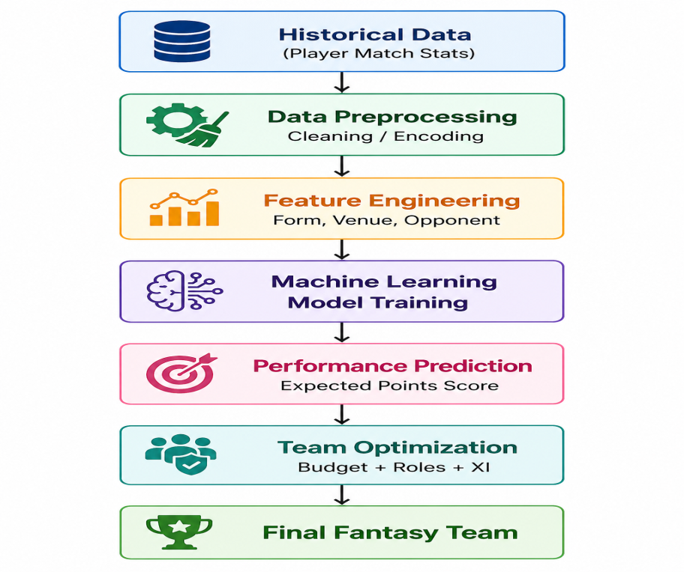
Proposed Solution
Overview
The proposed system is an intelligent Fantasy Team Selection System that utilizes Machine Learning techniques to predict player performance and recommend an optimal fantasy team for upcoming matches. The system replaces reliance on guesswork, intuition, and solely historical scores by incorporating a data-driven approach.
The model performs analysis on multiple factors, including historical player statistics, recent performance trends, venue conditions, opponent strength, and other match-related variables to generate accurate performance predictions.
The primary objective of the system is to maximize fantasy points through the selection of players with the highest probability of strong performance. The system is designed to be adaptable across multiple sports domains such as cricket, football, basketball, and other fantasy-based games where structured player data is available.

Architecture / Block Diagram

Modules Description
Data Collection Module
The data collection module is responsible for gathering historical sports data from APIs, websites, and structured datasets. The collected information includes player name, performance statistics such as runs, goals, assists, and wickets, efficiency metrics such as strike rate or passing accuracy, match venue, opponent team details, recent form indicators, and injury status.
Data Preprocessing Module
The preprocessing module ensures data quality by addressing inconsistencies present in raw datasets. Operations include removal of missing values, elimination of duplicate records, standardization of data formats, encoding of categorical variables using techniques such as label encoding, and application of feature scaling where required.
Feature Engineering Module
The feature engineering module derives meaningful attributes from raw data to enhance predictive accuracy. Engineered features include average fantasy points over the last five matches, historical performance against specific opponents, comparison of home versus away performance, venue-based performance ratios, consistency scores, and captaincy potential scores.
Machine Learning Prediction Module
The prediction module involves training and evaluation of multiple machine learning algorithms to estimate player performance. Algorithms considered include Linear Regression, Random Forest Regressor, XGBoost, Support Vector Machine, Artificial Neural Networks, and Long Short-Term Memory networks for time-series analysis. Model selection is based on performance metrics such as prediction accuracy and generalization capability.
Working Principle
The system begins with input of match details, where a specific upcoming match is selected. Player statistics corresponding to both teams are then retrieved from the dataset. The trained model predicts expected fantasy points for each player based on learned patterns. Following prediction, an optimization process selects the most suitable playing eleven by considering constraints such as budget limits, role distribution, maximum players per team, and assignment of captain and vice-captain roles. The final output consists of a recommended fantasy team.
Optimization Algorithm
Team selection is achieved using optimization techniques that balance performance and constraints. Greedy algorithms provide rapid initial selection, genetic algorithms explore optimal combinations through evolutionary strategies, and linear programming ensures adherence to budget constraints while maximizing total predicted score.
Deep Learning Enhancement
Long Short-Term Memory networks are incorporated to capture temporal dependencies in player performance. Such models analyze sequential match data to identify trends and performance streaks, thereby improving prediction accuracy compared to traditional machine learning methods.
Dataset Description
The dataset includes multiple attributes such as player name, match date, primary performance statistics including runs or goals, secondary statistics such as wickets or assists, opponent team, venue, fantasy points as the target variable, and recent form calculated as the average performance over the last five matches.
Expected Output
The system generates an optimized playing eleven along with captain and vice-captain recommendations. Additional outputs include predicted fantasy scores, assessment of player risk levels, and identification of alternative player options.
Advantages of the Proposed System
The system minimizes manual analysis effort by leveraging automated data processing and predictive modeling. Decision-making is based on real data rather than subjective estimation, leading to improved accuracy and higher probability of success. The approach enables rapid team generation and adapts effectively to new matches and evolving data. The system also supports multiple sports domains.
Future Improvements
Potential enhancements include integration of real-time injury and news updates, incorporation of weather impact analysis, dynamic team adjustments based on live match conditions, implementation of explainable AI techniques for transparency in recommendations, and deployment as a mobile application for improved accessibility.

Expected Output
The system generates an optimized playing eleven along with recommendations for captain and vice-captain selection. It provides predicted fantasy scores for each player, evaluates the risk level associated with player selection, and suggests alternative players to improve flexibility in team composition.
Advantages of the Proposed System
The proposed system reduces the need for manual analysis by automating data processing and decision-making. It relies on real-world data instead of subjective estimation, leading to improved prediction accuracy and increased chances of success. The approach enables rapid team generation and adapts efficiently to new matches and evolving datasets. The system is also designed to support multiple sports domains.
Future Improvements
Further enhancements include integration of real-time injury updates and news feeds to improve prediction reliability. Incorporation of weather impact analysis can provide additional contextual accuracy. The system can be extended to support live score-based adaptive team adjustments. Implementation of explainable artificial intelligence techniques will improve transparency and user trust. Deployment as a mobile application can enhance accessibility and user experience.

Inference
Evaluation Metrics
The system performance is assessed using multiple evaluation metrics, including accuracy, precision, recall, F1 score, and mean absolute error. These metrics provide a comprehensive understanding of both classification and regression performance.
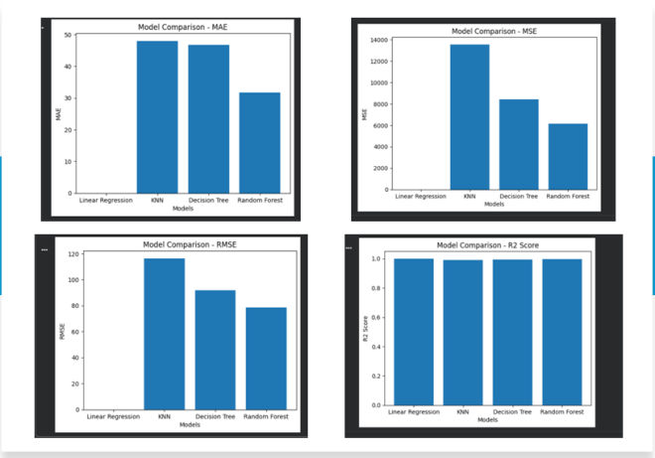
Model Comparison and Analysis
The results of different models are organized in a tabular format to enable effective comparison. Analysis indicates that combining multiple models through ensemble techniques produces better performance than relying on a single model, leading to improved prediction accuracy and overall system reliability.
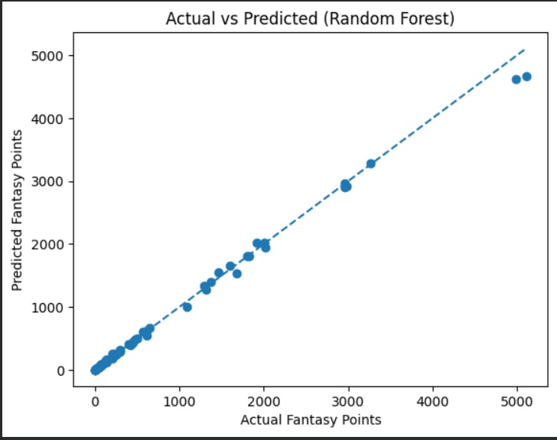

Conclusion
Conclusion
The study demonstrates that machine learning techniques significantly enhance the process of fantasy team selection by enabling accurate prediction of player performance. Models such as Random Forest and Artificial Neural Networks are effectively utilized to capture patterns in historical and contextual data.
The system supports data-driven decision-making, reducing reliance on subjective estimation and improving overall selection quality. Further improvements can be achieved through the integration of real-time data sources and the adoption of more advanced machine learning models to enhance prediction accuracy and system performance.

References
- Anderson, P. (2022). Predictive Analytics in Fantasy Sports. Journal of Sports Data Science.
- Sharma, V. (2020). Machine Learning Approaches for Cricket Performance Prediction. International Journal of Computer Applications.
- Patel, K. (2021). Data-Driven Decision Making in Fantasy Leagues. Springer.
- Nguyen, H. (2023). Time Series Forecasting using LSTM Networks. IEEE Transactions on Neural Networks.
- Garcia, M. (2019). Optimization Algorithms in Team Selection Problems. Elsevier.
- Singh, A. (2022). AI-Based Player Ranking Systems in Sports. IEEE Conference.
- Chen, Y. (2024). Ensemble Learning Techniques for Sports Prediction. Journal of Artificial Intelligence Research.
- Verma, S. (2021). Feature Engineering for Sports Analytics. Springer Publications.
- Lopez, D. (2020). Big Data in Sports Performance Analysis. Journal of Big Data.
- Reddy, P. (2023). Neural Networks for Predictive Modeling in Games. IEEE Access.

